Adobe download for home use directions
- First make sure that you have been given a user license agreement with adobe. Herzog will assign this to you.
- Login at school to make sure that your account is alive and active and you aren’t having any issues.
- Open up Chrome or any browser. Go to Adobe.com, click on sign in at the top right corner of the webpage and…
  - Type in your school email address and click continue
  - Chose personal account
  - Type in password, click continue
  - When it prompts you to add a mobile phone number, click “not now”.
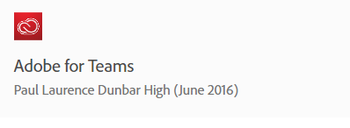
- Click on the blue circle at the top right of the webpage, click on your name. Make sure that under the Adobe for Teams part it says “Paul Laurence Dunbar High (June 2016), if it doesn’t then sign out, use a different browser, and repeat this process.
- Once this is verified, then scroll down and under common tasks, click on the “view and download my apps” link.
- Follow the prompts to download the programs that you want installed.
- Once desired programs are installed, launch the application.
- The program will either ask you to sign in with a sign in screen of which you can do and enter your school email and adobe password you setup, or you may have to go to the help menu through the program itself and click “sign in” that way.
- After this you should be good, but if for some reason you get stuck along the way, come see Herzog!

