KENTUCKY TSA STATE CONFERENCE CODE OF CONDUCT
Knowing that any organization is partly judged by the behavior of its individual members, we who attend the Kentucky Technology Student Association State Conference consent that our registering at the state conference constitutes our subscribing to the following rules that comprise the Code of Conduct for the Kentucky Technology Student Association.
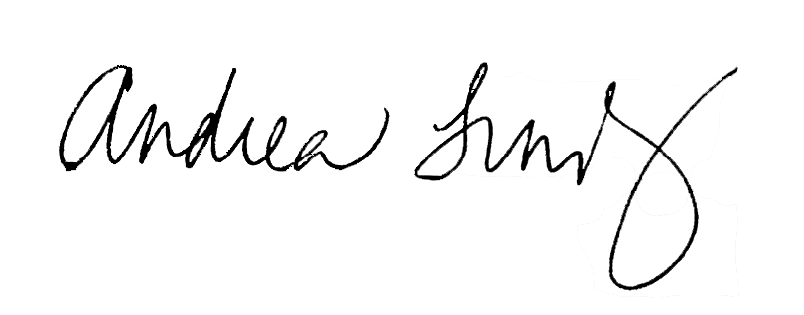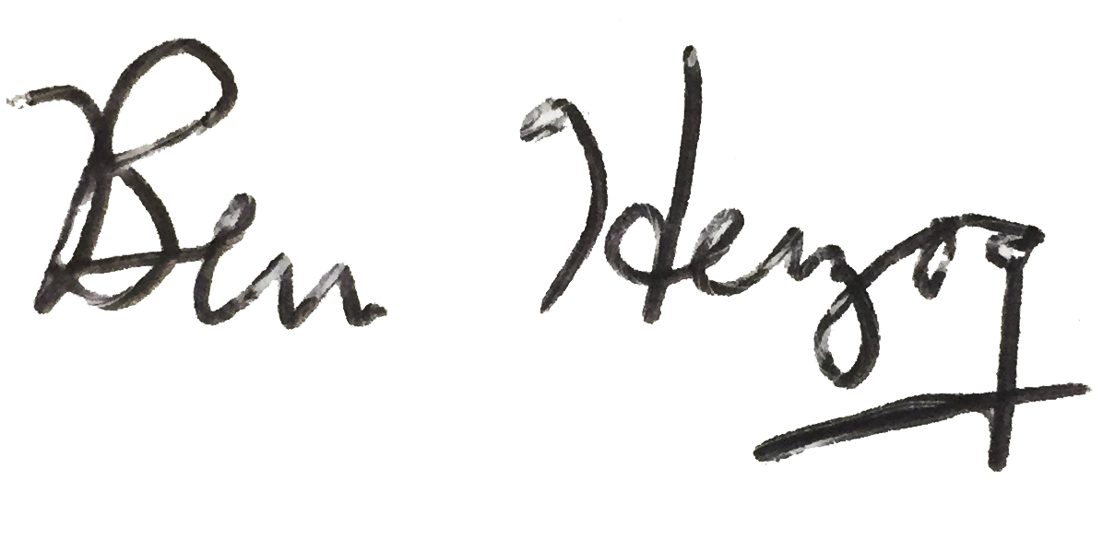1. All chapter members attending the KY TSA State Conference are required to attend all General Sessions and activities for which they are registered; foreseeing a conflict, such as overlapping of curricular events, the competitor or advisor will inform the curricular event coordinators.
2. There shall be no defacing of public property. Any damages to the property or furnishings in the hotel rooms or building must be paid by the individual(s) and/or parents/guardians.
3. Advisors are responsible for each one of his or her chapter members. Therefore, members must keep their advisor informed of their activities and whereabouts at all times.
4. Members should be prompt and prepared for all activities.
5. Smoking or using any tobacco product will not be permitted at the state conference by chapter members.
6. No member shall leave the conference hotel (except for authorized events) unless permission is granted from the chapter advisor(s). When leaving the hotel, stay in groups of at least three or four.
7. Identification badges must be worn at all times by all persons in attendance at the conference.
8. Members shall show proper identification before removing any equipment, displays, or items used in competitions from the conference site.
9. Members will be in their assigned rooms by designated curfews and will remain in their rooms during the curfew period. Curfew times are listed in the conference program.
10. Visitation of male and female members in hotel guest rooms is not encouraged. Permission from advisors of both parties must be obtained before visitations can take place. It is the responsibility of the chapter advisors to provide proper supervision between visitations of the opposite sex.
11. Members will be appropriately dressed for all official functions. Conference attire guidelines can be found HERE.
12. Members will not use profanity or make obscene gestures or perform acts that would mar the image of our organization.
13. Members shall not participate in any activity that might cause personal injury to themselves or to another member. Any member found in violation of hotel safety codes or criminal laws may be sent home at the student’s/parents’ expense. The chapter advisor will contact the parents and school principal.
14. The practice and testing of equipment shall only be performed in designated areas and by no means are to be conducted in the hotel hallways, lobby, or parking lot.
15. Members shall sleep in the rooms for which they are registered.
16. Members shall be considerate and respect the rights of their roommates and other hotel guests by refraining from behavior that may disturb others. Do not make excessive noise or have music or TV at a high volume.
17. Conference participants shall not possess or consume alcohol, drugs, or any form of artificial stimulant while traveling to, during, or returning from the conference site. (Drugs prescribed by doctors are permissible.) Violators will be expelled from the conference and turned over to the proper authorities. Chapter advisors will notify parents and the school principal of the action taken.
18. The State Director has the right to take immediate action when violations occur, including sending individuals home at their own expense.
All other infractions shall be dealt with as follows:
1st Offense - Conference with student and school TSA advisor.
2nd Offense - Meeting with school TSA advisor.
3rd Offense - State Director makes final decision to call parents and send home.
KENTUCKY TECHNOLOGY STUDENT ASSOCIATION STATE CONFERENCE CODE OF CONDUCT SIGNATURE FORM
We agree that any violation of the Code of Conduct subjects our entire chapter to be sent home and all honors and awards forfeited. Misconduct on our part shall be reported to our advisor, principal, and parents.
School ______PL Dunbar________________________________________________
Student’s Signature___________________________________ Best Contact Number _______________________
Parent’s Signature____________________________________ Best Contact Number _______________________
Principal’s Signature__________________________________ Best Contact Number ___859-381-3546_________
Advisor’s Signature___________________________________ Best Contact Number ___859-381-3546_________

